Name: Abdurrahman Qureshi

Roll no: 210451

- Write a program in C to implement koch curve. Code:

#include<stdio.h>

#include<conio.h>

#include<graphics.h>

#include<stdlib.h>

#define SIN 0.86602540 // sin(60 degrees)

void koch(int x1,int y1,int x2,int y2,int m)

{

int xx,yy,x[5],y[5],lx,ly,offx=50,offy=300; lx=(x2-x1)/3;

ly=(y2-y1)/3;

x[0]=x1; //store point p0

y[0]=y1;

x[4]=x2; //store point p4

y[4]=y2;

x[1]=x[0]+lx; //store point p1

y[1]=y[0]+ly;

x[3]=x[0]+2*lx; //store point p3

y[3]=y[0]+2*ly;

xx=x[3]-x[1]; //translate point p2

to origin

yy=y[3]-y[1];

x[2]=xx*(0.5)+yy*(SIN); //perform

rotation for point p3 y[2]=-xx*(SIN)+yy*(0.5);

x[2]=x[2]+x[1]; //perform inverse translation

y[2]=y[2]+y[1];

if(m>0)

{

koch(x[0],y[0],x[1],y[1],m-1);

koch(x[1],y[1],x[2],y[2],m-1); koch(x[2],y[2],x[3],y[3],m-1); koch(x[3],y[3],x[4],y[4],m-1);

}

else

{

line(offx + x[0],offy + y[0],offx + x[1],offy + y[1]);

line(offx + x[1],offy + y[1],offx + x[2],offy + y[2]);

line(offx + x[2],offy + y[2],offx + x[3],offy + y[3]);

line(offx + x[3],offy + y[3],offx +

x[4],offy + y[4]);

}

}

void main()

{

int n,gd=DETECT,gm;

int x1=0,x2=550,y1=0,y2=0;

clrscr();

initgraph(&gd,&gm,"C:\\TC\\BGI");

printf("\n Enter the level of curve generation:

");

scanf("%d",&n);

detectgraph(&gd,&gm);

koch(x1,y1,x2,y2,n); //draw koch curve

closegraph();

getch();

}

Output:
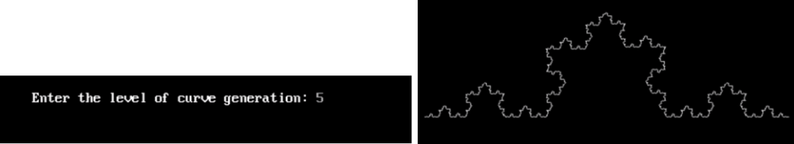

Q) Write a program in c to implement Bezier curve.

Code:

#include <stdio.h>

#include<conio.h>

#include <stdlib.h>

#include <graphics.h>

#include <math.h>

void bezier (int x[4], int y[4])

{

int gd = DETECT, gm;

int i;

double t;

initgraph (&gd, &gm, "C:\\TC\\BGI"); for (t = 0.0; t < 1.0; t += 0.0005) {

double xt = pow (1-t, 3) * x[0] + 3 * t * pow (1-t, 2) * x[1] +

3 * pow (t, 2) * (1-t) * x[2] +

pow (t, 3) * x[3];

double yt = pow (1-t, 3) * y[0] + 3 * t * pow (1-t, 2) * y[1] +

3 * pow (t, 2) * (1-t) * y[2] +

pow (t, 3) * y[3];

putpixel (xt, yt, WHITE);

}

for (i=0; i<4; i++)

putpixel (x[i], y[i], YELLOW);

getch();

closegraph();

return;

}

void main()

{

int x[4], y[4];

clrscr();

int i;

printf ("Enter the x- and y-coordinates of the four control points.\n");

for (i=0; i<4; i++)

scanf ("%d%d", &x[i], &y[i]);

bezier (x, y);

getch();

}

Output:
